Name : Sk . Kashifa

Registration no :192121135

Beauty parlour appointment

Use case diagram :

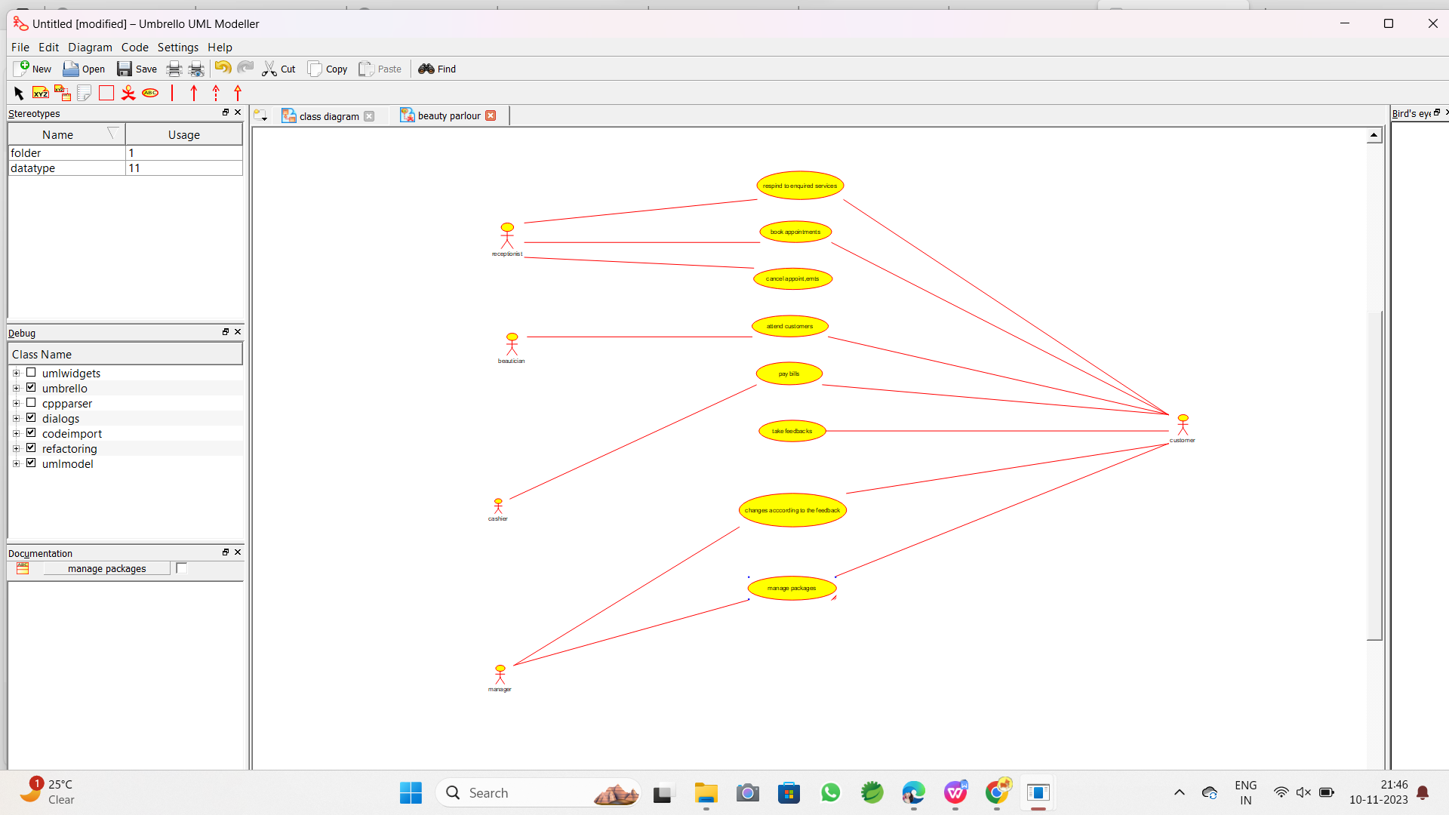

Class diagram:

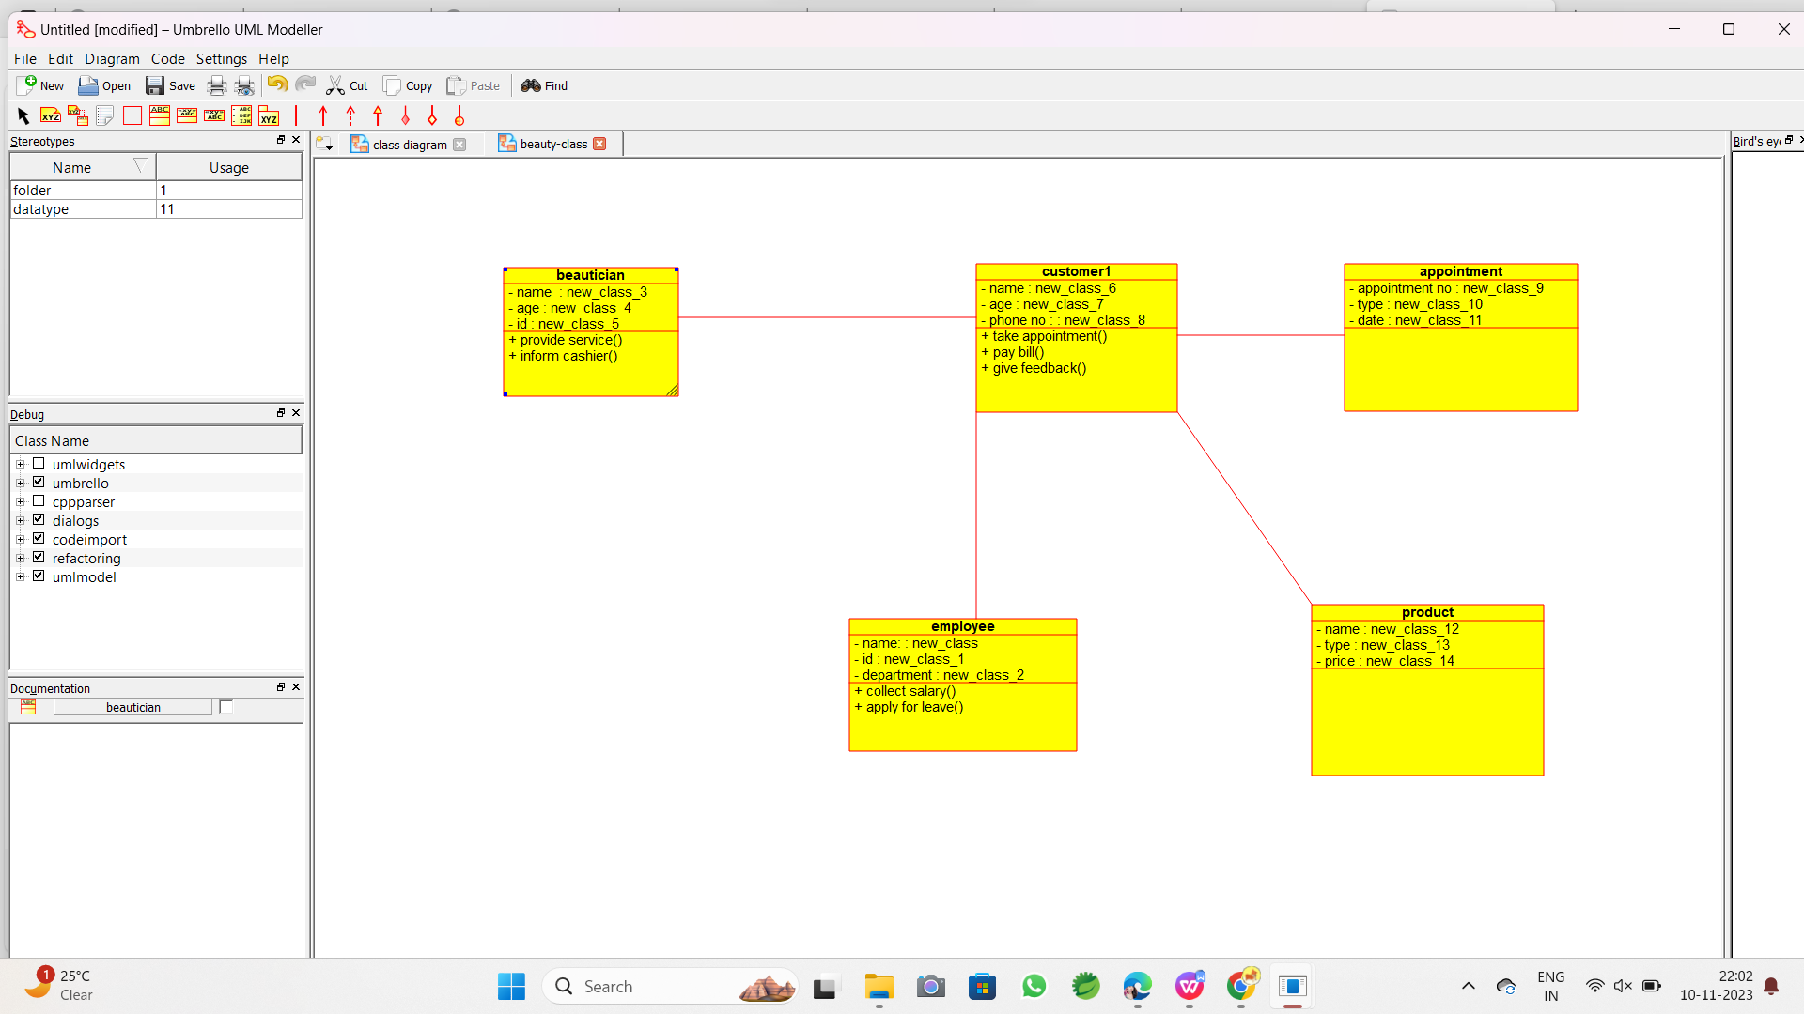

Component diagram :

